Egg Carton Seed Starter

Materials:

- Egg Carton
- Soil
- Seeds
- Water
- Plastic Wrap

Instructions:

- Cut lid off of the egg carton, set aside
- Poke holes into the bottom of each cell with a pen or pencil
- Fill egg carton with soil
- Poke a small hole in the soil of each cell
- Place seed in hole
- Cover with thin layer of soil
- Place bottom of the egg carton inside the lid
- Water each cell
- Cover egg carton with plastic wrap
- Set in a warm sunny place in your house

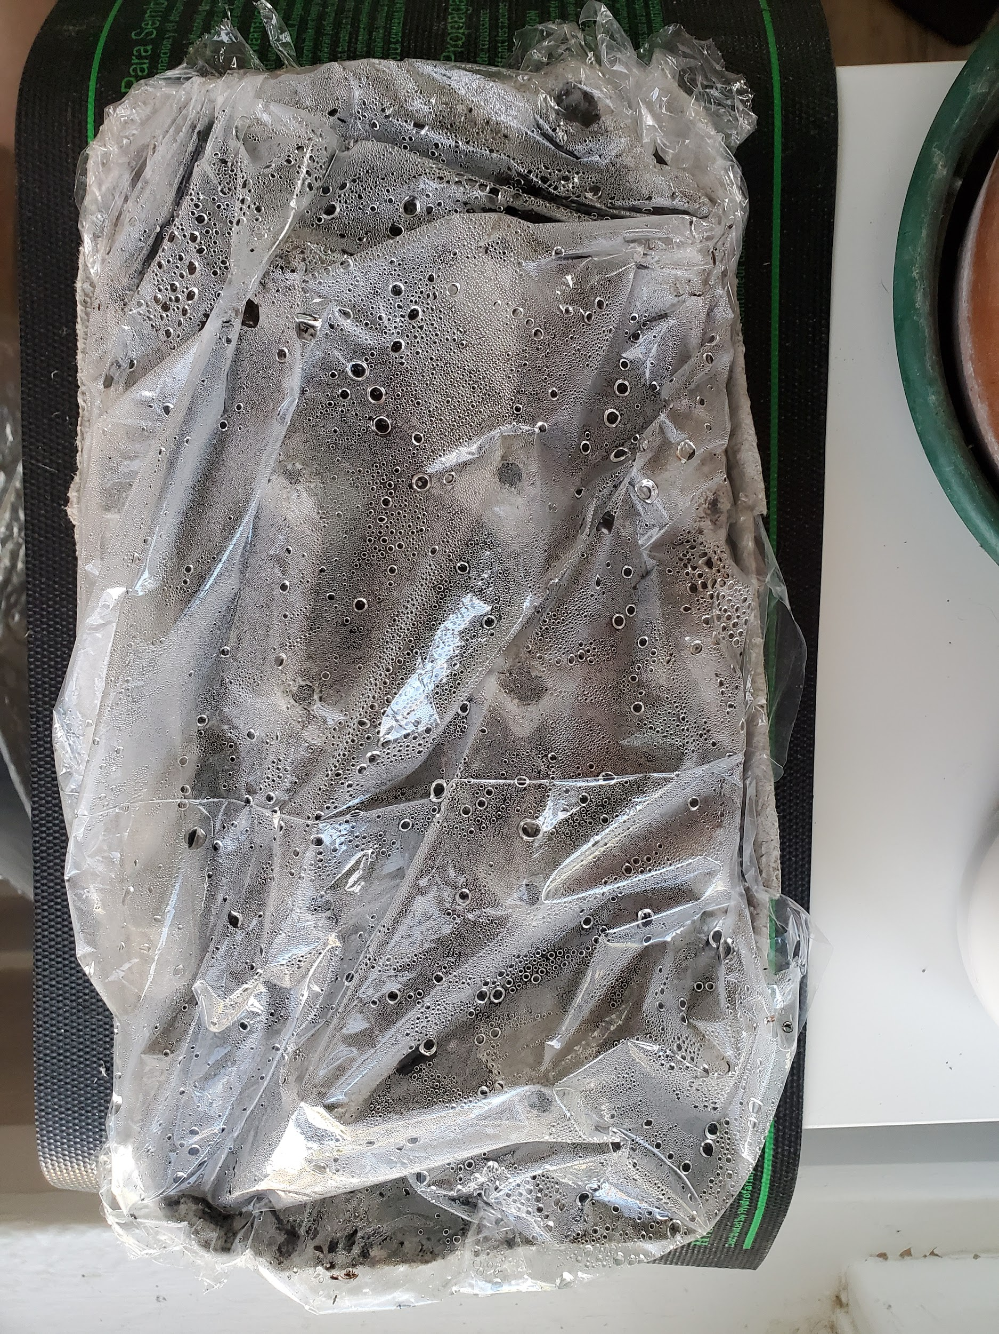
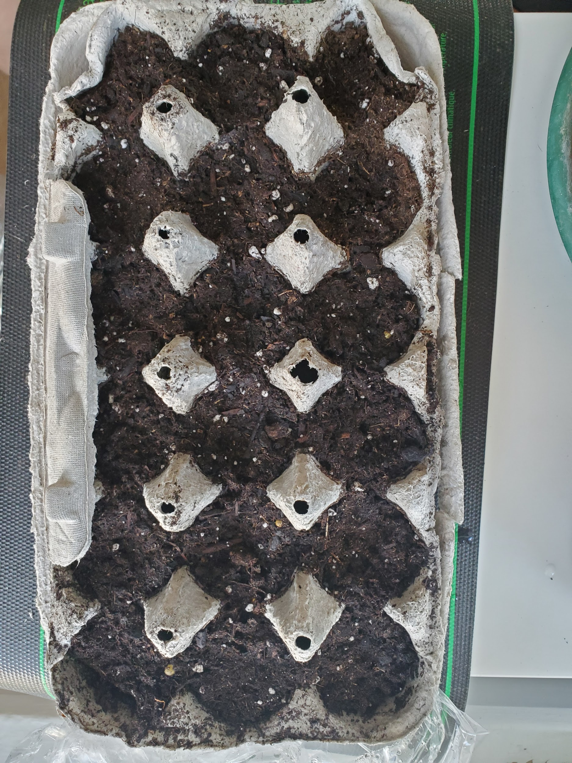

Show us your seed starter and seedlings! Get permission from a family member to post a picture on Facebook or Instagram and use the hashtag #cectv!

